# ST.XAVIER’S COLLEGE

# MAITIGHAR, KATHMANDU



**LAB ASSIGNMENT #7**

**Computer Graphics**

**Submitted By:**

Bishal Pandey

013BSCCSIT016

4TH Sem, 2nd Year

**Submitted To:**

______________________

Er.Anil K Sah

Lecturer

Department of Computer Science

**Statement: To rotate, translate and scale the picture.**

**Algorithm: Translation**

Step 1: Input the value of Tx and Ty.

Step 2: x= Height;

y= Width;

Step 3: i=0

continue until x is greater than i.

continue until y is greater than j.

then

a=i+Tx;

b=j+Ty;

Step 4: Print the image after translation.

**Algorithm: Scaling**

Step 1: Input the value of Sx and Sy.

Step 2: x= Height;

y= Width;

Step 3: i=0

continue until x is greater than i.

continue until y is greater than j.

then

a=i*Tx;

b=j*Ty;

Step 4: Print the image after scaling.

**Algorithm: Rotation**

Step 1: Input the value of theta(in degree) for which the image should be rotated.

Step 2: x =Heightof image

y=Width of image

Step 3: i=0

continue until x is greater than i.

continue until y is greater than j.

then

a=i*Tx;

b=j*Ty;

Step 4: int a = i*cos(theta)-j*sin(theta);

int b = j*cos(theta)+i*sin(theta);

Step 5: Print the image after rotation.

**SOURCE CODE**

#include <vcl\vcl.h>

#pragma hdrstop

#include "Unit1.h"

#include "math.h"

//---------------------------------------------------------------------------

#pragma resource "*.dfm"

TForm1 *Form1;

int x,y,Tx,Ty,a,b,i,j,theta;

//---------------------------------------------------------------------------

__fastcall TForm1::TForm1(TComponent* Owner)

: TForm(Owner)

{

}

//---------------------------------------------------------------------------

void __fastcall TForm1::TranslateClick(TObject *Sender)

{

Tx=StrToInt(Edit1->Text);

Ty=StrToInt(Edit2->Text);

x=Image1->Height;

y=Image2->Width;

for(i=0;i<x;i++)

{

for(j=0;j<=y;j++)

{

a=i+Tx;

b=j+Ty;

Image2->Canvas->Pixels[a][b]=Image1->Canvas->Pixels[a][b];

}

}

}

//---------------------------------------------------------------------------

void __fastcall TForm1::ScaleClick(TObject *Sender)

{

Tx=StrToInt(Edit1->Text);

Ty=StrToInt(Edit2->Text);

x=Image1->Height;

y=Image2->Width;

for(i=0;i<x;i++)

{

for(j=0;j<=y;j++)

{

a=i*Tx;

b=j*Ty;

Image2->Canvas->Pixels[a][b]=Image1->Canvas->Pixels[a][b];

}

}

}

//---------------------------------------------------------------------------

void __fastcall TForm1::RotationClick(TObject *Sender)

{

int theta =StrToInt(Edit3->Text);

int x = Image1->Height;

int y = Image1->Width;

for(i=0;i<=x;i++)

{

for(j=0;j<=y;j++)

{

int a = i*cos(theta)-j*sin(theta);

int b = j*cos(theta)+i*sin(theta);

Image2->Canvas->Pixels[a][b] = Image1->Canvas->Pixels[i][j];

}

}

}

//-----------------------------------

**OUTPUT**

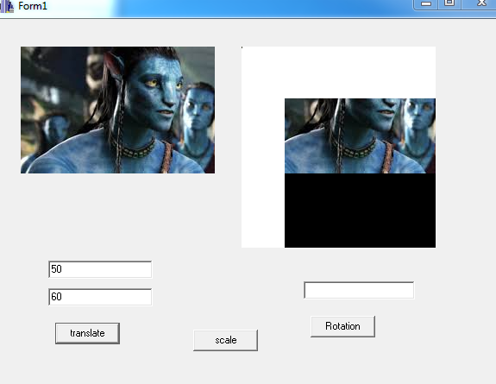

**Translation**

**Rotation**

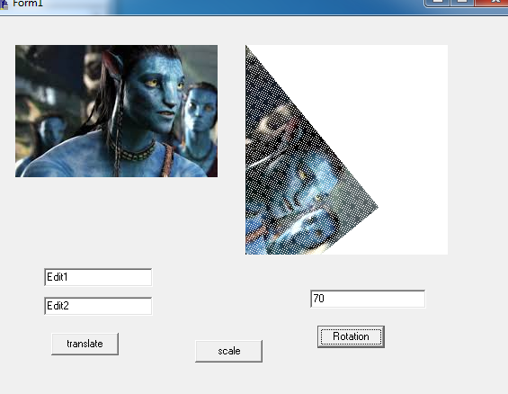

**Conclusion**

Hence, we can translate, rotate and scale the image using C++ Builder.